Building Blocks and Elements for a Business Enterprise

As more companies leverage the power of technology to build better businesses, the question is no longer “if” they will undergo a [digital transformation](https://www.simplilearn.com/digital-transformation-training/), but rather “how fast.” MCkinsey identifies six building blocks that high-performing digital enterprises should be able to adapt in order to build their digital quotient.

1. Strategy and innovation
2. The customer decision journey
3. Process automation
4. Organization
5. Technology
6. Data and analytics

According to McKinsey, 90% of digital leaders have fully integrated digital into their strategic planning process. McKinsey advises not to look at past analysis but to carve a strategy based on what you believe your sector will look like in three to five years. Then focus on the most significant opportunities.

McKinsey also talk about the blurring between strategy and execution.

I believe innovation should be an integral part of business objectives. It’s hard to find (or imagine) a business without growth cooked into the future strategy. In our work we see many businesses that still see digital as simply a website, app or social tool that is an add on to their business. They don't truly put digital at the centre of their business strategy and are not prepared to reinvent their businesses for the digital age. Of course, this is understandable as true digital strategy involves massive change not only in technology but also in people and culture, process.

Mckinsey research "shows that organisations that are able to understand and skillfully act on complete customer journeys can reap enormous rewards. These businesses increase customer satisfaction by up to 20 percent and revenue growth by 10 to 15 percent, and lower the cost to serve by 15 to 20 percent." McKinsey see understanding the customer decision journeys as a cornerstone for successful business.

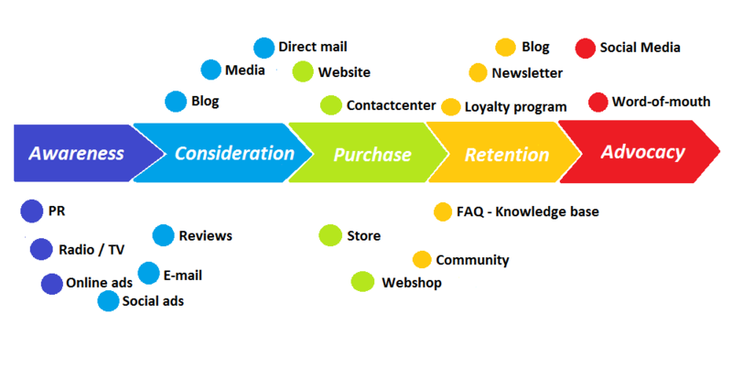

That’s true because, I believe, as a customer, if you don’t give me the quality experience I expect; exactly what I want, how, when and where I want to experience it, I’ll simply get it from someone else who will.  And companies like Google, will make sure that I do. [Google](https://www.google.com/about/company/philosophy/), Apple and Amazon are just a few among the many mega-companies who have made it their mission to cater the world to the individual customer. With each[new algorithm release](https://www.linkedin.com/pulse/mobileggedon-what-dont-tell-you-googles-new-algorithm-gary-deasi?trk=prof-post), Google is making it more and more difficult for companies to be found online through search if they are failing to deliver the level of [quality experiences](http://contentmarketinginstitute.com/2015/04/google-judges-quality/) customers demand. And when customers do have negative experiences, they are often quick to share their complaints with their social networks. In a moment’s notice, a single bad experience and a single tweet can cause some really serious damage to a brand.  A few years back, one unhappy United Airlines customer who had a bad experience posted a youtube video about it and [cost the airline $180m](http://white.net/blog/united-airlines-lose-millions-youtube/) as its share price dropped 10%. (It’s no wonder the stock of Customer Experience has risen so high over the past few years.)

The modern customer demands to be treated as an individual; for their digital experiences and communications to be personalized and highly-relevant, and catered to match their specific needs, interests, and preferences.  In order to give customers what they want, how, when, and where they want it, marketers need to [understand the customer journey](http://customerjourneymarketer.com/understand-b2b-customer-journey/).

Three statements from the McKinsey article on automation should be taken on board by every SME:

* "Business-process automation can result in massive competitive advantage because initial investments, when well implemented, can scale quickly without substantial additional costs".
* "While there is often the assumption that process automation is a large project focused on a major platform, digital leaders in fact drive value quickly by focusing on a series of small but important solutions that target high-value customer journeys and expectations (for example, real-time availability and personalized treatment)."
* "Becoming digital often requires reinventing the entire business process to cut out steps altogether or reduce the number of documents required."

I totally agree that automation is impacting every marketing touchpoint. A marketer can manage multiple accounts, track a prospect, monitor his behavior, make a sales pitch in real time or run a drip campaign. This way, he can grow his business using automation solutions.

In the words of McKinsey:

* "Companies know that rigid, slow-moving models no longer cut it. The challenge is to move toward a structure that is agile, flexible, and increasingly collaborative while keeping the rest of the business running smoothly."
* "Some 65 percent of digital leaders have a culture that isn’t afraid of risks, for example, and have a high tolerance for bold initiatives."

In my opinion smaller organizations can become digital more quickly - senior management just needs to take the plunge.

* They set a broad long-term vision for the business (where they want to be over a 3 or 5 year period).
* They quickly set about getting quick wins in the short term.

On the technology front, digitization is based on two pillars. First, a scalable [cloud platform](https://cloud.telekom.de/en/cloud-infrastructure/open-telekom-cloud/), which allows companies to start on a small scale and yet supports business growth needs. And second, secure and stable connectivity enabling the highly networked scenarios of the [Internet of Things](https://www.t-systems.com/de/en/solutions/digitization/digitization-topics/internet-of-things/machine-to-machine-communication-245680) (IoT) and Industry 4.0 at any location and with any device.

In accordance with that High-performance analytics lets you do things you never thought about before because the data volumes were just way too big. For instance, you can get timely insights to make decisions about fleeting opportunities, get precise answers for hard-to-solve problems and uncover new growth opportunities – all while using IT resources more effectively.

So, how does the above factors are incorporated into business process management?

BPM is a practice that aims to model, measure, improve and optimize business processes. No customer is exactly the same so generic processes cannot possibly account for their varying needs. The modern world requires more than a one-size-fits-all kind of approach to process management.

Business process is a standardized way to convert a set of inputs into a desired output that a customer would find valuable.

So how exactly a business process works?

**OUTPUT**

**INPUT**





For example, a loan application at a bank! A customer applies an electronic application via a bank website. That’s an Input! The business process itself consists of credit check and other activities that enables the bank to make a decision whether to approve of loan or not. The out put of the business process is a decision that is communicated to the customer followed by the money being paid to the correct customer’s bank account.

So here, the primary output is the money that the customer wants to borrow.

The secondary output is the email notifying the customer of the decision.

The 6 pillars of BPM are *strategic alignment, governance, methods, information technology,* *people* and *culture*. All six aspects need to work for a BPM project to be a success. The business process needs to be fit for purpose and actually satisfy the demands of stakeholders. People aspect also needs to work, if a customer neglects required information, the web page will alert him or her that the application form is incomplete. If a manager forgets to approve a certain process step, she will get an alert and if she still ignores it the alert will escalate to her manager and the process owner will also get an alert that the process is stuck. This level of visibility if impossible to achieve without a good technology. For the automation to run smoothly, the information needs to work seamlessly all of the time. It takes a large team of experts with IT and business knowledge to implement a BPM project. The project team studies a related set of business process in great detail and they try to re-design it with the objective of optimizing it so it is fit for purpose. This happens during the design phase of the process where the processes are carefully designed to be as simple and straightforward as possible, so it can be completed in the shortest possible amount of time without making mistakes. During the modelling and simulation phase of the project, the process is documented in the form of an activity model. It is impossible to simulate the behavior of the system and try out different scenarios through the what-if approach. Once the process is approved by the management it is employed, this occurs during the execution phase of the project. The project team will then monitor the business process to see if anything goes wrong, this is the monitoring phase. If any problem arise, changes will be made to further optimize the process to take care of exceptions. This occurs during the optimization phase of the process. A good BPM implementation will increase the visibility of the bank’s activities, making it easy to monitor and control the critical business processes of the bank. It provides management with increased ability to identify bottlenecks, making improvements when needed and re-assigned resources to meet customer demand. Good BPM system will only contribute significantly to reduce real-times, so the customer hears about the decision of the bank within days or other than weeks. It ensures better definition of duties and the roles of the employees of the company. It prevents the unfortunate situation where a customer who called up to enquire about a loan application is transferred to the one individual to the next and to the next and they transfer him to the person who deals with it. Business Process management uses a cross-functional approach where the work is automatically moved from one desk to next without manual intervention. Once a system is operational the process is yet not complete, the team needs to get the customer feedback and make further improvement. In general, all the six principals of business process management need to be followed to ensure success.

Citations:

Rosemann, Michael, and Jan Vom Brocke. “The Six Core Elements of Business Process Management.” *Handbook on Business Process Management 1*, Nov. 2014, pp. 105–122., doi:10.1007/978-3-642-45100-3_5.